**UCS 2611 Internet Programming Lab**

**Exercise 1: Implementation of Conference Website using HTML**

**Date of Exercise: 30.01.2024**

1. Create the following sample web page using necessary HTML elements

**Sample Webpage**

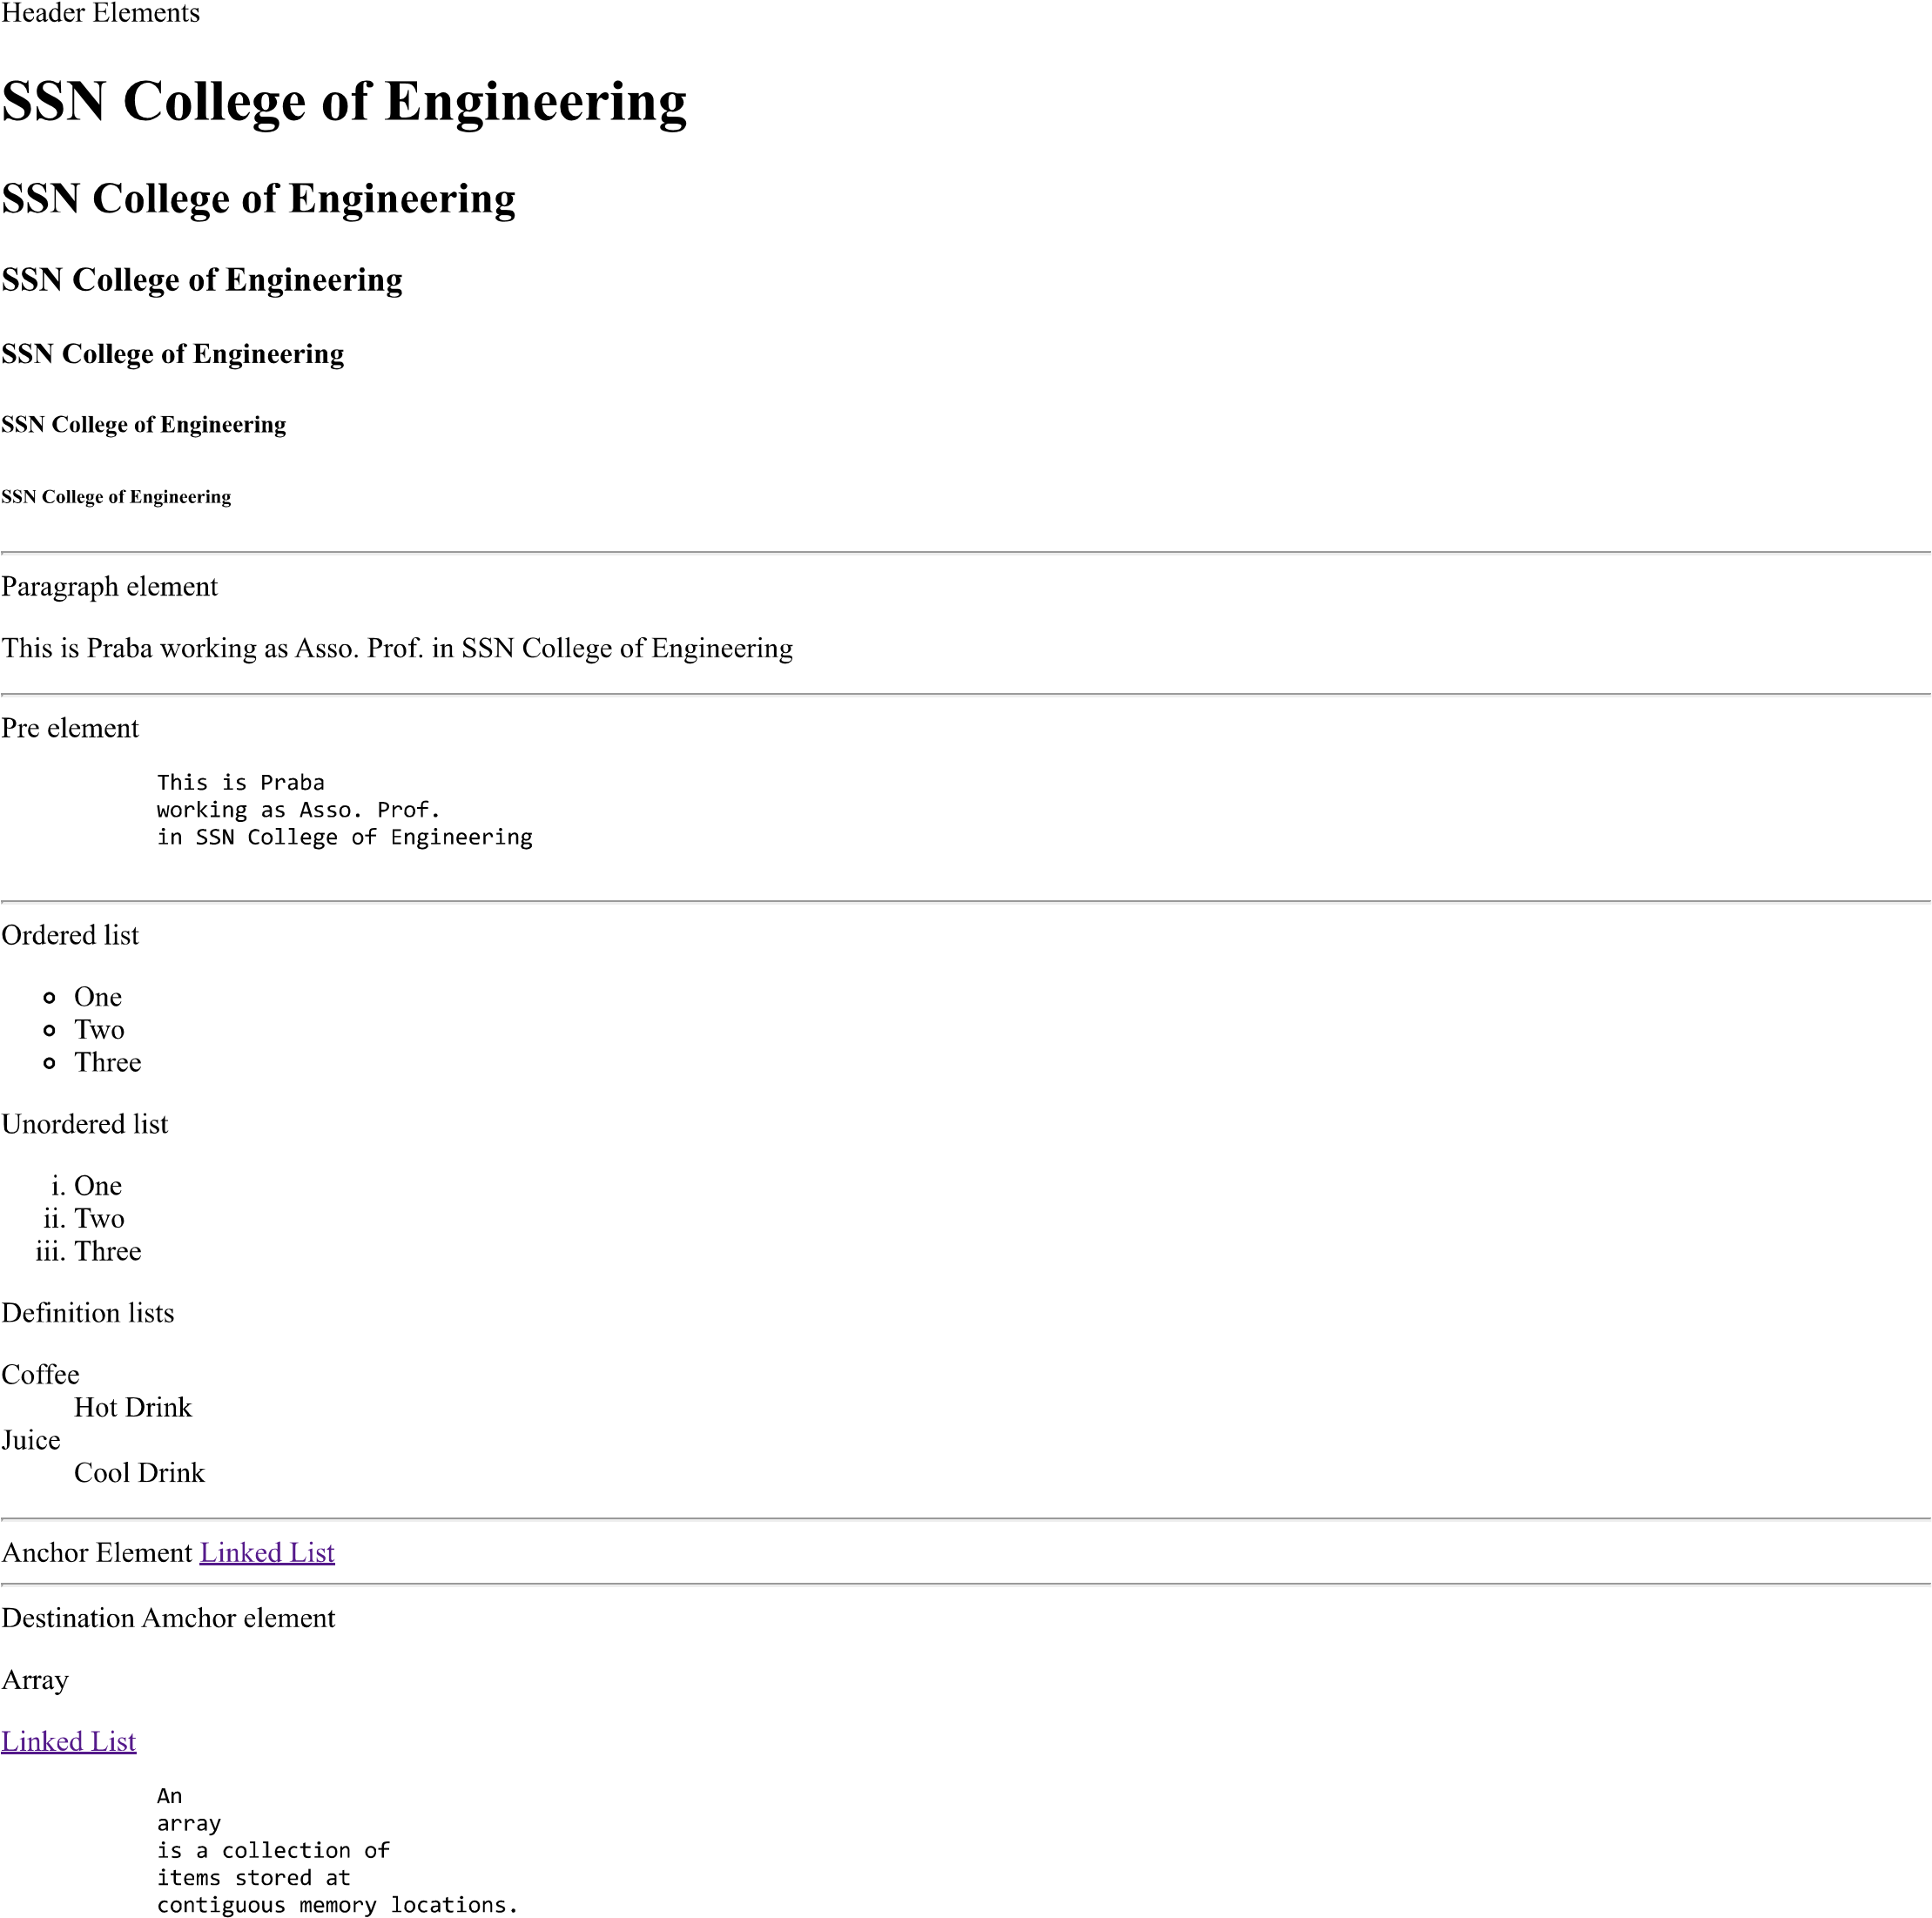

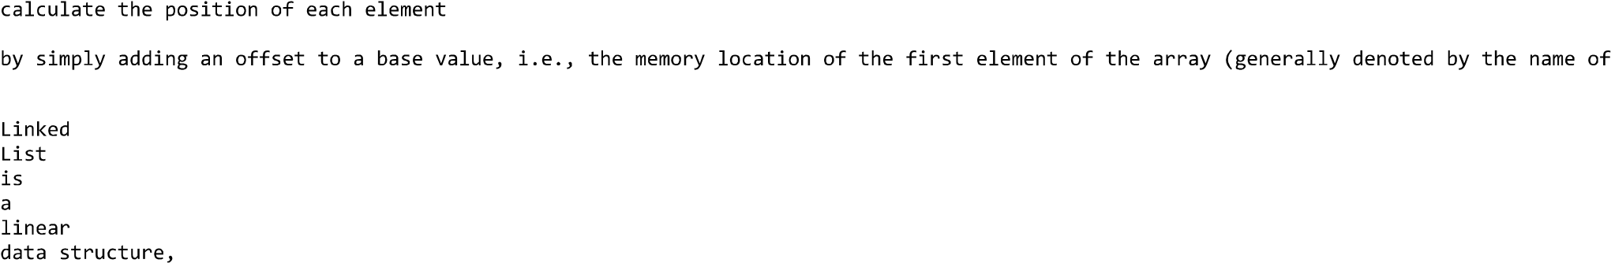

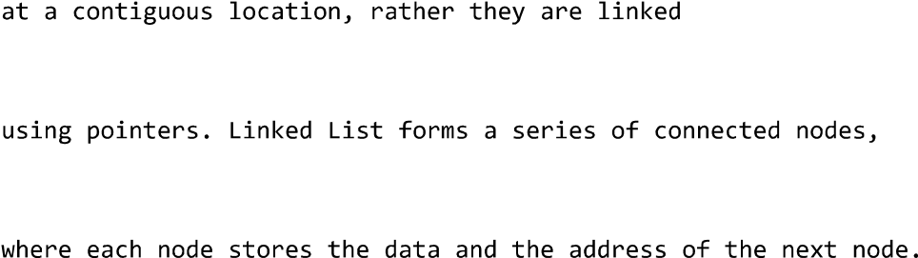

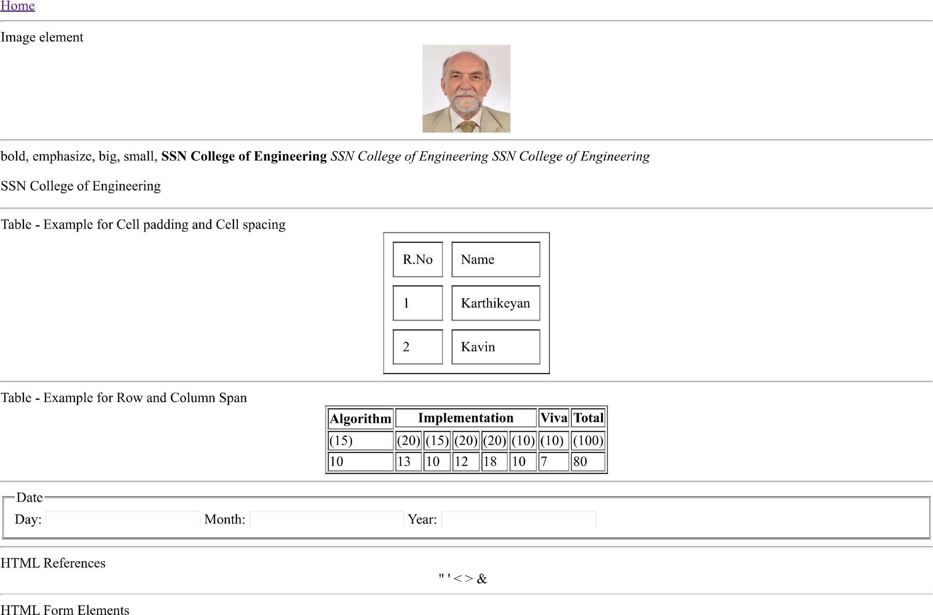

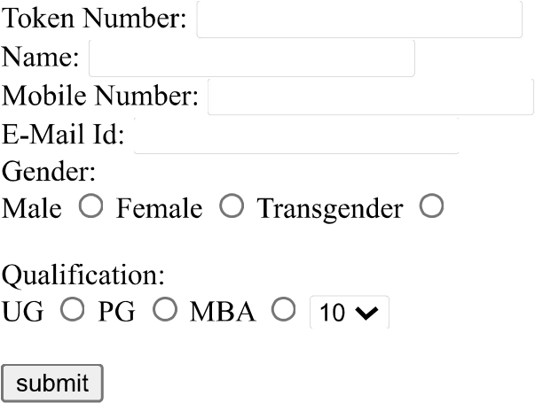

Create the following conference web site using necessary HTML elements

**Conference Website – ICCIDS**

